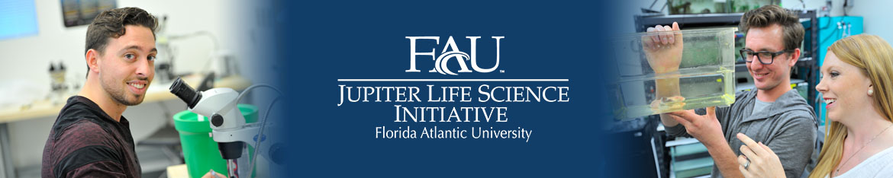

bringing science to life on the FAU Jupiter campus
The 2019 John Nambu Memorial Summer Research Experience for Undergraduates (REU) Program
Intensive research opportunities await FAU undergraduate students this summer (May 13 – July 19, 2019). These are exciting and once-in-a-lifetime chances to perform research in sophisticated life science labs while expanding your laboratory expertise. Cutting-edge FAU Jupiter labs are seeking undergraduate students this summer to perform biology, neuroscience, and psychology research. More information about participating labs and their Principal Investigators can be found at http://www.fau.edu/jlsi/faculty/index.php.
The successful undergraduate candidates will work 28 hours per week in the lab and will attend weekly mentoring sessions with fellow program participants and coordinator Dr. Cathy Trivigno. Students often complete a thesis through the program. The program runs full-time during the summer, with the option of continuing research into the academic year. A summer stipend is included.
Sophomores and Juniors are especially encouraged to apply. In order to submit your application: complete the attached application and forward it with your CV/resume, personal statement and (unofficial) transcript to Glenn Malone at gmalone@fau.edu by March 1, 2019.
Please direct questions about the program to Glenn Malone at gmalone@fau.edu, or visit Glenn in MC-19 Room 108, 561-799-8051.

Did you know?
Multimillion dollar funded research labs are in operation at FAU Jupiter:

The Jupiter Life Science Initiative
The Brain Institute

YOU can do research in this growing life science community!

FAU’s Jupiter Life Science Initiative unites scientists from the Charles E. Schmidt Colleges of Science and Medicine with the Harriet L. Wilkes Honors College in research and training programs.

The John Nambu Memorial Summer Research Experience for Undergraduates (REU) Program
Application

Z# _

Last name: _______________________ First name: __________________ MI: ____

Address: _____________________________________________________________

City: State: Country:____________

Phone: _______________________________ Email: ___________________@fau.edu

Please indicate below the name(s) of the life science faculty in whose labs you are interested (select up to three and rank them in order of preference with 1 being the highest):

Alex Keene Carmen Varela

Erik Duboué Greg Macleod

Henriette van Praag Johanna Kowalko

Laura Vernon Lucia Carvelli

Randy Blakely Robert Stackman

Rod Murphey Tanja Godenschwege

Other life science faculty member: ____________________________

If you have specific skills applicable to life science research (e.g., laboratory experience, photomicrography, video recording, use of computer packages, statistics), please indicate:

Career goals after obtaining undergraduate degree:

Membership in professional and honor societies, honors and awards:

I certify that the information given in this application is complete and accurate.

Signature: ___________________________________________ Date: __________________

Send this application, your CV/resume, personal statement and (unofficial) transcript to Glenn Malone - gmalone@fau.edu.

Submission Deadline: March 1, 2019

