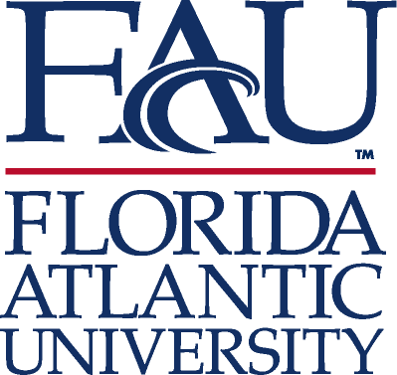
The John Nambu Memorial Summer Research Experience for Undergraduates (REU) Program
Application

Z# _
Last name: _______________________ First name: __________________ MI: ____

Address: _____________________________________________________________

City: State: Country:____________

Phone: _______________________________ Email: ___________________@fau.edu

Please indicate below the name(s) of the neuroscience and behavior-oriented faculty in whose labs you are interested (select up to three and rank them in order of preference with 1 being the highest):

Ken Dawson-Scully (Boca campus) Rod Murphey (Jupiter campus)

Kailiang Jia (Boca campus) Tanja Godenschwege (Jupiter campus)

Alex Keene (Jupiter campus) Greg Macleod (Jupiter campus)

Robert Stackman (Jupiter campus) Erik Duboué (Jupiter campus)

Randy Blakely (Jupiter campus) Lucia Carvelli (Jupiter campus)

If you have specific skills applicable to biological research (e.g., laboratory experience, photomicrography, video recording, use of computer packages, statistics), please indicate:

Career goals after obtaining undergraduate degree:

Membership in professional and honor societies, honors and awards:

I certify that the information given in this application is complete and accurate.

Signature: ___________________________________________ Date: __________________

Send this application, your CV, personal statement and (unofficial) transcript to Dr. Trivigno - trivigno@fau.edu.

Submission Deadline: March 1, 2018

