Department of Biological Science Charles E. Schmidt College of Science Boca Raton Campus, SC 136  Tel. 561-297-3320 | Biological Sciences  Master’s Program | 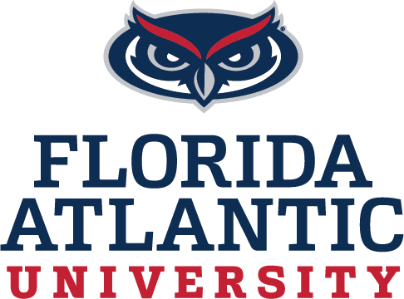
Graduate Student Biology Faculty Advisor Verification Form
Prior to acceptance into the Biology graduate program, each student must have an FAU Biology Departmental Advisor (please see the following link for FAU Biology Departmental Faculty – listed under the “College of Science” http://biology.fau.edu/home/biology_ms_program_faculty.php The FAU Biology Faculty Advisor who signs agrees to supervise the student's graduate program. Professors not listed under the Institution: "College of Science" will need an FAU Biology Departmental Faculty member to co-sign with them.

See Guidelines for Biology Masters Degree at link below for more information.
https://biology.fau.edu/formsandpolicies/graduate_student.php
I have agreed to be the FAU Biology Faculty advisor for: Please print student name and Date
Biology Faculty Advisor name (please print)
Biology Faculty advisor signature and date:
(If Professor is not listed under College of Science, a FAU Biology co-advisor is required)

Co-Advisor name (please print)
Co-Advisor Signature and date:

Semester: Fall Spring________

Masters Degree Options: Please Check One of the following.
Master Thesis
BS/MS Bachelor of Science/Master of Science (for Molecular Biology/ Biotechnology Students 5 year program)

PSM (Professional Science Master in the Business of Biotechnology)
MS (Non-Thesis Option #1)
MST (Non-Thesis Option #2)

