Department of Biological Science Charles E. Schmidt College of Science Boca Raton Campus, SC 136  Tel. 561-297-3320 | Biology Faculty Advisor  Verification  Form | 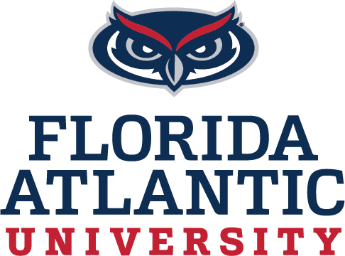
What is a FAU Biology Advisor?
The FAU Biology Departmental Advisor is the Chair of your MS Committee. As such, they help you, the student, achieve your educational and professional goals by working closely with you to finish the degree in a timely fashion. From the first semester through to the last semester they will work with you on courses and research (when applicable) that would give you the skills and connections needed to complete your degree, including Thesis research, Non-thesis Comprehensive Exams, and Internships in Professional Science in Business Biotechnology.
See Guideline for Biology Master’s degree at link below for more information and for the Biology Faculty List
https://biology.fau.edu/formsandpolicies/graduate_student.php
Instructions:
- Find Biology Advisor in your area of interest (listed under the “College of Science”) see link above for list.
- Fill out all information below and have advisor sign.
- If Professor is not listed under College of Science, a FAU Biology co-advisor is required)
- Turn Form into a PDF to have Faculty Member sign (if not signing in person)

I have agreed to be the FAU Biology Advisor For:

Student Name:

Biology Faculty Advisor Name:
Biology Faculty Advisor Signature and date

If Professor above is not listed under “College of Science”, An FAU Biology Co-advisor is required
Biology Co-Advisor Name:
Biology Co-Advisor Signature and date:

Master’s Degree Options: Please select one of the Following
Master’s Thesis
MS (Non-Thesis Option 1)
MST (Non-Thesis Option 2)
PSM (Professional Science Masters in the Business of Biotechnology
BS/MS Bachelor of Science/Master of Science

