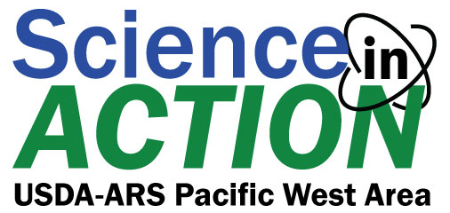

2024 Undergraduate Summer Training Program Application

The purpose of the “Science-in-Action” 2024 Summer Training Program is to strengthen long-term partnerships between the United States Department of Agriculture’s (USDA) Agricultural Research Service (ARS) and four-year Minority Serving Institutions and increase internship recipients’ competitiveness for obtaining career opportunities within the USDA-ARS.
Objectives:
- Create opportunities for students from under-represented groups who have an interest and aptitude in agricultural sciences
- Provide students with hands-on experience working in a scientific environment with world-renowned scientists on cutting edge research
Award Benefits: Each award provides:
- 8-week paid summer employment at an ARS laboratory in the Pacific West Area (California, Washington, Utah, Oregon, Arizona, Hawaii, Nevada, or Idaho)
- Funding for housing and roundtrip travel to location
- Mentoring network
- Potential renewal for a second summer (contingent upon successful completion of prior year and normal progress toward a bachelor’s degree)
- Potential college credit
General Eligibility: Applicant must:
- Be a U.S. citizen or have Permanent Resident status
- Currently attend and have completed at least one year of attendance at a four-year Minority Serving Institution
- Have a cumulative GPA of 3.0 or better (on a 4.0 scale)
- Major in an area of study associated with agriculture, horticulture, forestry, food science, nutrition, natural resources, or related sciences
*(Students graduating in the Spring of 2024 are ineligible to apply)
Application Deadline: All application materials must be emailed or postmarked no later than Friday, February 9, 2024 and sent to chandra.holifield@usda.gov or Science-in-Action, c/o Chandra Holifield Collins, 2000 E. Allen Rd., Tucson, AZ 85719.

Biographical Information:
Legal Name in Full:
Permanent Home Address:
Gender:
Telephone: (Home)
(Cell)
Email Address:
Are you a U.S. Citizen or Permanent Resident? Yes / No

Education:
Name of college or university you are currently attending:
Cumulative GPA:
Declared/Intended Major:
Expected graduation date:
College Address:

Resume and Transcripts:
You must include a current resume and obtain an official signed and sealed transcript from every college or university you have attended and include them with your application. The “Science-in-Action” Summer Training Program will accept an unofficial transcript from the college registrar provided it meets the deadline and a receipt from the registrar is included indicating an official, signed transcript is being sent.

Recommendation Instructions:
You will need to submit two letters of recommendation (one must be from an academic source) addressing the following question: “Considering what you know of the applicant’s interests, work habits, and life goals, what is your assessment of the chances that the applicant will be motivated to take advantage of the opportunities available in college and with the USDA-Agricultural Research Service?” All letters should be emailed directly from the source to chandra.holifield@usda.gov.
Please provide an attachment with answers to the following questions:
1) How did you become interested in the study of food, agriculture, and natural resource sciences or related college disciplines?

2) What person or life event has had the greatest influence in your choice of educational path and its role in or towards a possible career?

3) Describe an experience where you had a leadership role in school or within your community. Give a recent example of a positive impact resulting from your leadership contribution(s).

4) Please describe how the Science-in-Action Summer Training Program meets your needs/interests. What do you expect to gain from the program and what can you contribute to the experience? (approx. 400 words)
Please rank your top 3 (1, 2, 3) research interests for your internship experience:
______ Aquaculture
______ Hydrology
______ Plant Pathology
______ Natural Resources
______ Plant Genetics and Breeding
______ Crop Production
______ Remote Sensing
______ Plant Science
______ Entomology
______ Food Science
______ Bioinformatics
______ Plant Germplasm Resources
______ Chemical Ecology
______ Other __________________________________________

